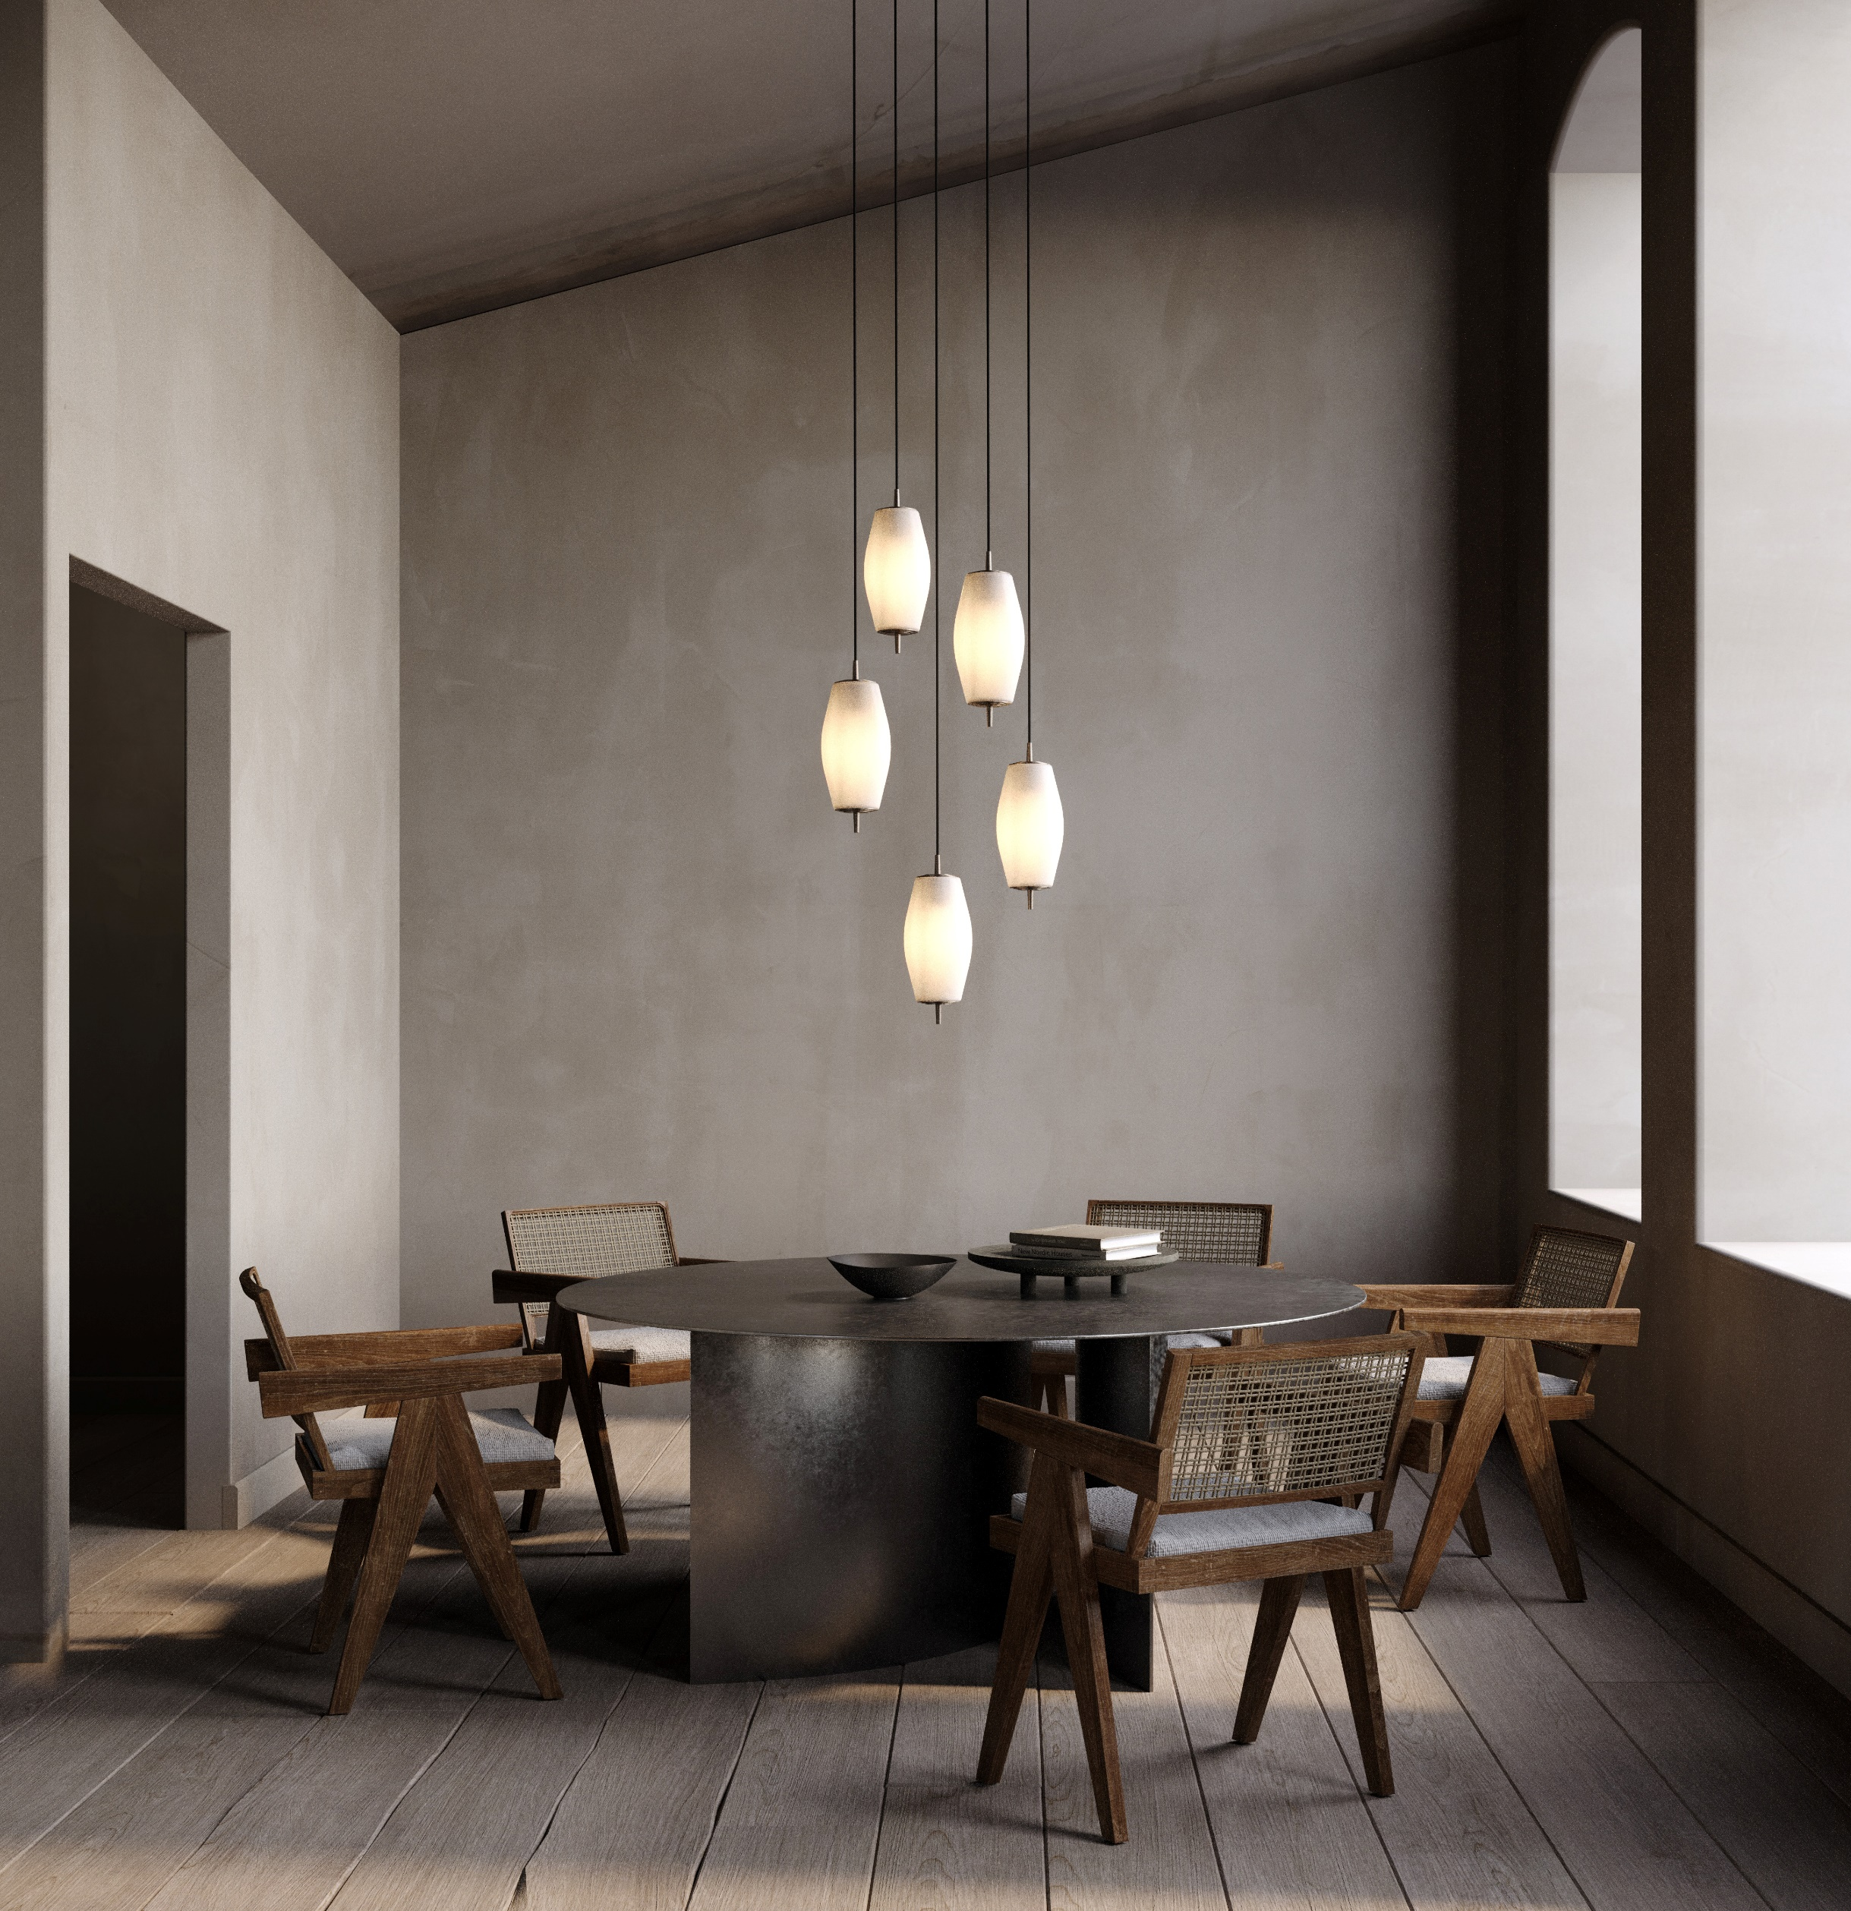

Introducing the Nova Slim:
A stellar new pendant light from J. Adams & Co.

- Launching at Decorex International 2022 -

The last addition to the popular Nova series will make its debut at Decorex 2022: the Nova Slim. With a graceful, slender profile that explores form and reimagines the traditional globe, Nova Slim has a modernist aesthetic with an Art Deco edge.

Cluster together at varying heights for a contemporary statement piece or opt for a practical lighting solution by suspending in a row of three over a kitchen island or countertop.

Exploring the sculptural possibilities of glass, each shade is expertly mouth-blown and sandblasted to create a soft, porcelain-like texture. Sculptural when ‘off’, the orbital shade comes to life when ‘on’, providing a warm, ethereal atmosphere.

Appearing to pierce through the glass shade, a lustrous tapered stem with unique stepped detailing anchors the design and incorporates the brand’s signature use of solid machined brass. Made in England and available in an antique brass or bronze finish, the Nova Slim will make a compelling addition to any interior.

For high resolution imagery, videos, quotes and product loans, please contact: info@jadamsandco.com

Notes to Editors :
Founded in 2016 and led by Creative Director Will Earl, J. Adams & Co. showcase craftsmanship, innovative engineering and authentic design made in Britain. Combining an industrial aesthetic with modern elements, J. Adams & Co. redefine classic styles in contemporary form to create their timeless collections. Materiality and manufacturing expertise are at the heart of the brand, with each product made by hand in the companies UK Birmingham factory using only the highest quality materials.

